**REPORT**

**Database Management And Database Design**

**Project Item 3**

**Team Members:**

Nikhil Dharane – 001409173

Kaviya Sachi – 001387786

Varun Senthil – 001434831

Anuja Suryawanshi – 001383812

**Contents:**

Abstract........................................................................................................................................................3

Entity Relationship Diagram.........................................................................................................................3

Entity Relationship Diagram.........................................................................................................................4

Scope Of Database Schema..........................................................................................................................5

Business Rules..............................................................................................................................................5

User Privileges..............................................................................................................................................6

DDL Queries………....................................................................................................................................9

Citation.......................................................................................................................................................35

**Abstract:**

The purpose of this project is to provide the fund management firm with the strategies to filter the clients based on their portfolio for optimal investment plan with the less involvement of risks and man-force through automation. This report contains Entity Relationship Diagram which shows the relationship of all the entity sets that are in the database. Also, the business rules, scope of the database schema and all the tables used are provided.

**Entity Relationship Diagram:**

An entity relationship diagram (ERD) shows the relationships of entity sets stored in a database. An entity in this context is an object, a component of data. An entity set is a collection of similar entities. These entities can have attributes that define its properties. By defining the entities, their attributes, and showing the relationships between them, an ER diagram illustrates the logical structure of databases.

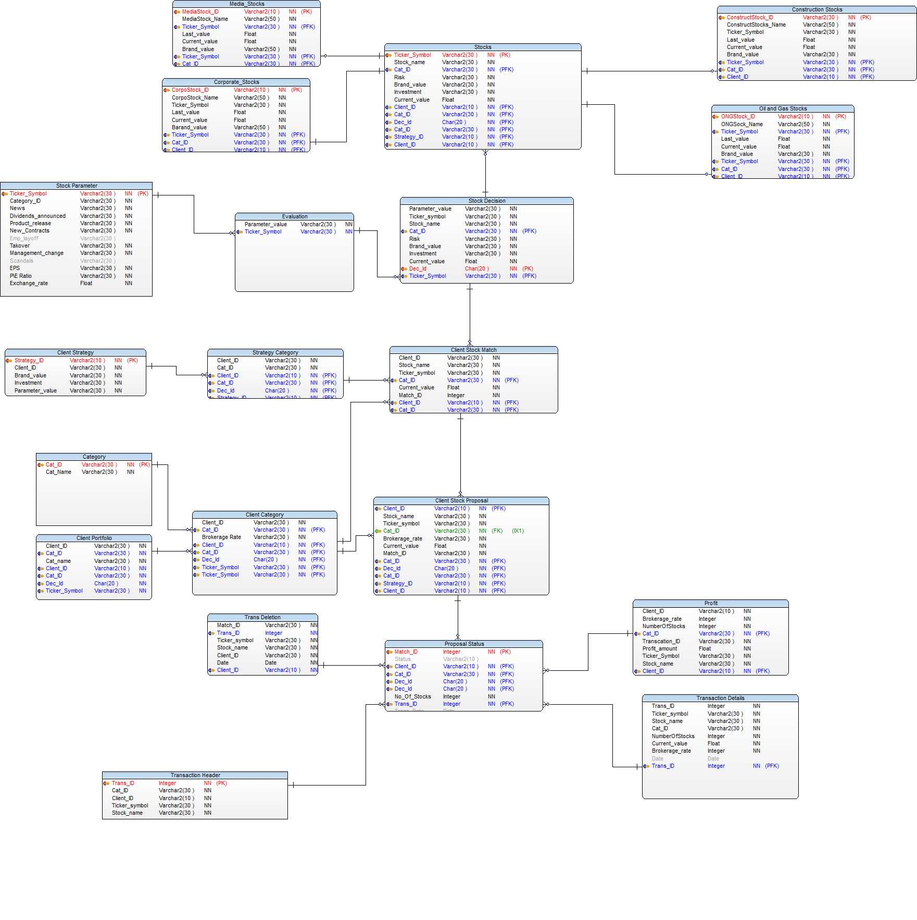

**Scope of Database Schema:**

The scope of the project is proposing Stock to Client which matches their area of interest using their previous portfolio.

The Rules of Interest:

* 1. Stock
  2. Category
  3. Brokerage Rate
  4. Stock Value
  5. Stock Condition
  6. Client
  7. Stock Proposal

**Business Rules:**

* Every Client-Stock proposal should have a unique transaction ID
* Profit is calculated as a product of number of stocks and brokerage rate
* Transaction id is used to track the transaction header and all the minor details
* Transaction date is created using the system timestamp and must be in the format MM-DD-YY
* All the accepted proposals will be tracked using transaction details and all the details for deleted proposals will be tracked using transaction deletion
* Number of stocks when the proposal is accepted must be one or greater than one but not zero or null
* Every parameter condition must not be null and should have a certain value associated with it.
* Every parameter condition must have a value that is within its range
* The finally evaluated parameter value for a stock should not be null and must not be greater than 100
* The ticker symbol must always be unique when referring to a stock
* The change value for a stock in the staging level must reflect as the current value for the stock in the deployed database tables
* The ticker symbol should be a unique sequence of 3 letter and cannot be null for a particular stock
* The match id and transaction id must be unique and not null
* SSN, contact number of the client should not be null and must not be greater than 10 digits
* Email, city, state and zip code of the client must not be null
* Client name, and client id must be unique and cannot be null
* Every Stock_Proposal should be Accepted/Rejected by the client
* A client is associated with one or more Stocks
* Based on Stock_Parameter, Evaluation must be performed and categorized as Extremely High/High/Moderate/Low/Extremely Low.
* Stock_Decision is made by evaluating the Evaluation and Stock_Table
* Every Client may have zero, one or more than one strategy
* Every Client must have one or more stock categories of interest
* The Client can accept zero, one or more than one stock proposal
* Every stock is evaluated first and proposed to the client only if the client minimum conditions are met for the stock
* Every stock must have only one category
* The particular one stock can be proposed to multiple clients if the client minimum conditions are met for the stock
* The particular stock cannot be proposed to an individual client multiple times.
* Every stock must have the current stock value.
* Every stock proposed to a particular client must have a unique match_id
* Every proposed stock must include the brokerage rate
* Every proposed stock must have either 'accept' OR 'Reject' status to be processed further
* Every parameter condition like News, Dividends announced, Product Release, must be greater than or equal to the expected parameter_value from the client's side
* A client have one and only one SSN.
* The Stock_Table can have wide range of stocks from History table, but no stocks should be repeated.

**User Privileges:**

Access given to two users Admin and user (i.e. Client). Admin has all the rights to add, update, insert into database. Also maintain and manage the database. User has access to Client, Client portfolio, Proposal Status tables.

**Admin privileges:**

create user Admin identified by Admin;

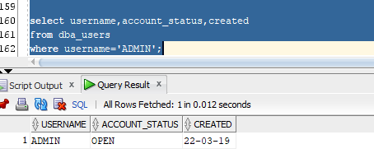

Giving connect privilege to Admin

grant connect to Admin;

Granting resource(allows to create procedure/triggers)

grant resource to Admin;

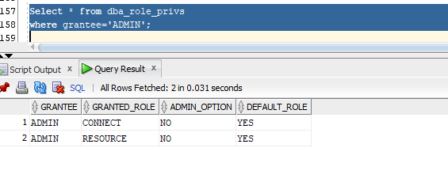

Connect successful for ADMIN

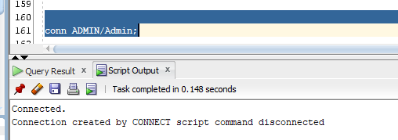

**Granting Role1 to Admin**

**Queries for granting roles:**

create role ROLE1;

grant select_catalog_role to ROLE1;

grant execute_catalog_role to ROLE1;

grant DELETE_CATALOG_ROLE to ROLE1;

GRANT GRANT ANY OBJECT PRIVILEGE TO ROLE1;

**Granting Role1 privileges to Admin:**

grant ROLE1 to ADMIN;

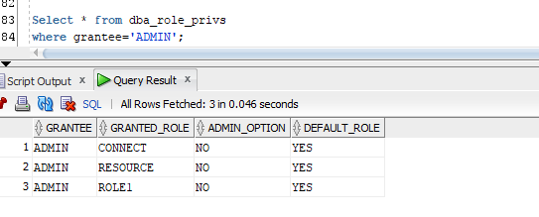

create user Client identified by Client;

grant connect to Client;

grant resource to Client;

conn CLIENT/Client;

GRANT SELECT ON client_portf TO CLIENT;

GRANT SELECT ON client TO CLIENT;

GRANT SELECT ON PROPOSAL_STATUS TO CLIENT;

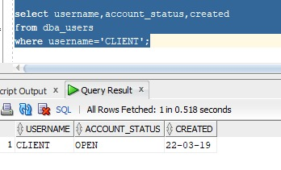

**DML And DDL SQL queries for Creating tables and Inserting sample data to test the integrity constraints of the sample data:**

**Healthcare sector table:**

**DDL Create:**

CREATE TABLE Healthcare (

"Stock_Name" Varchar(255),

"Ticker_Symbol" Varchar(10),

"Last_Value" Float,

"Change_Value" Float,

"Brand Value" Varchar(10),

"Cat_id" Varchar(10)

);

**DDL insert:**

insert into Healthcare values('Abbvie_Inc', 'ABBV', 80.43, 75.77, 'High', 'HEALTH01');

insert into Healthcare values('Aurora Cannabis Inc', 'ACB', 9.57, 78.77, 'Moderate', 'HEALTH02');

insert into Healthcare values('American Shared Hospital Services', 'AMS', 5.63, 2.63, 'Moderate', 'HEALTH03');

insert into Healthcare values('Cardiovascular Systems Inc', 'CSII', 39.54, 40.16, 'Low', 'HEALTH04');

insert into Healthcare values('Varian Medical Systems Inc.', 'VAR', 137.26, 132.26, 'Moderate', 'HEALTH05');

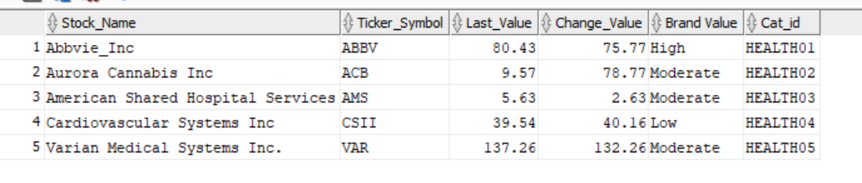

**Energy sector table:**

**DDL Create:**

CREATE TABLE Energy (

"Stock_Name" Varchar(255),

"Ticker_Symbol" Varchar(10),

"Last_Value" Float,

"Change_Value" Float,

"Brand Value" Varchar(10),

"Cat_id" Varchar(10)

);

**DDL insert:**

insert into Energy values('Hollyfrontier Corp', 'HFC', 52.32, 50.32, 'High', 'ENERGY01');

insert into Energy values('Pioneer Natural Resources CO', 'PXD', 144.32, 147.32, 'Low', 'ENERGY02');

insert into Energy values('Chevron Corp', 'CVX', 125.96, 121.96, 'High', 'ENERGY03');

insert into Energy values('Halliburton Company', 'HAL', 30.04, 30.52, 'Moderate', 'ENERGY04');

insert into Energy values('Schlumberger N.V.', 'SLB', 149.34, 145.34, 'High', 'ENERGY05');

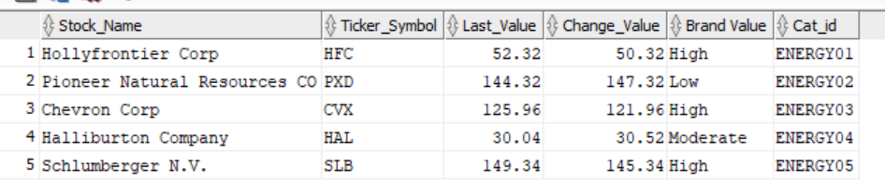

**Technology sector table:**

**DDL Create:**

CREATE TABLE Technology (

"Stock_Name" Varchar(255),

"Ticker_Symbol" Varchar(10),

"Last_Value" Float,

"Change_Value" Float,

"Brand Value" Varchar(10),

"Cat_id" Varchar(10)

);

**DDL insert:**

insert into Technology values('Apple Inc ', 'AAPL', 195.09, 190.32, 'High', 'TECH01');

insert into Technology values('Cognizant Tech Sol', 'CTSH', 71.49, 72.49, 'Moderate', 'TECH02');

insert into Technology values('Hewlett Packard Enterprise Comp', 'HPE', 15.89, 14.89, 'High', 'TECH03');

insert into Technology values('Nvidia Corp', 'NVDA', 175.33, 185.00, 'Moderate', 'TECH04');

insert into Technology values('Oracle Corp', 'ORCL', 52.63, 54.63, 'High', 'TECH05');

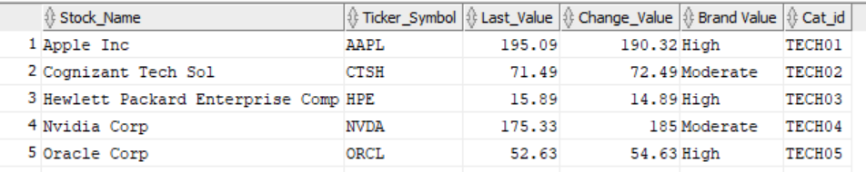

**Industrials sector table:**

**DDL** **Create**:

CREATE TABLE Industrials (

"Stock_Name" Varchar(255),

"Ticker_Symbol" Varchar(10),

"Last_Value" Float,

"Change_Value" Float,

"Brand Value" Varchar(10),

"Cat_id" Varchar(10)

);

**DDL insert:**

insert into Industrials values('Alaska Air Group', 'ALK', 55.02, 53.02, 'Low', 'IND01');

insert into Industrials values('Fedex Corp', 'FDX', 178.99, 174.39, 'High', 'IND02');

insert into Industrials values('Lockheed Martin Corp', 'LMT', 299.01, 294.03, 'High', 'IND03');

insert into Industrials values('Rockwell Automation Inc', 'ROK', 177.02, 173.02, 'Moderate', 'IND04');

insert into Industrials values('United Technologies Corp', 'UTX', 73.87, 72.23, 'Low', 'IND05');

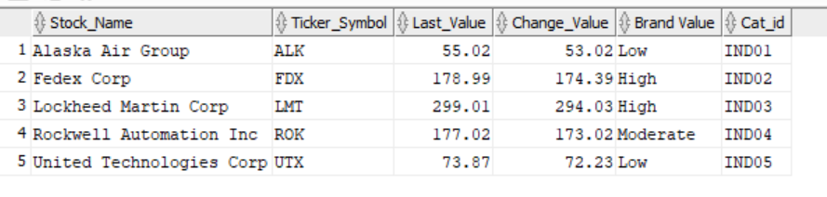

**ConsumerDiscretionary sector table:**

**DDL Create:**

CREATE TABLE ConsumerDiscretionary (

"Stock_Name" Varchar(255),

"Ticker_Symbol" Varchar(10),

"Last_Value" Float,

"Change_Value" Float,

"Brand Value" Varchar(10),

"Cat_id" Varchar(10)

);

**DDL insert:**

insert into ConsumerDiscretionary values('Chipotle Mexican Grill', 'CMG', 670.45, 660.45, 'Low', 'CONS01');

insert into ConsumerDiscretionary values('Footlocker Inc', 'FL', 59.82, 60.44, 'Moderate', 'CONS02');

insert into ConsumerDiscretionary values('Gap Inc', 'GPS', 25.12, 27.1, 'Moderate', 'CONS03');

insert into ConsumerDiscretionary values('Macys Inc', 'M', 60.45, 63.45, 'Low', 'CONS04');

insert into ConsumerDiscretionary values('Ebay Inc', 'EBAY', 37.39, 33.39, 'High', 'CONS05');

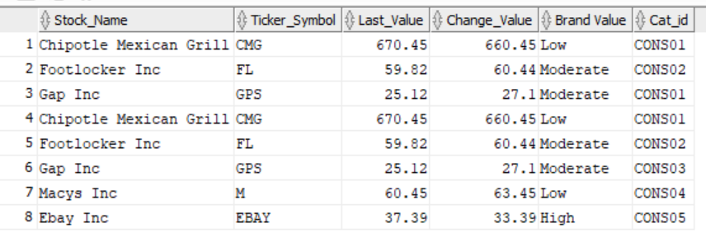

**Client_portfolio:**

**DDL Create:**

create table client_portf(

Client_Id varchar(5) NOT NULL,

Category_Name varchar(25) NOT NULL,

Cat_ID Varchar(25) NOT NULL

);

**DDL Insert:**

insert into Client_portf values ('ID01','Banking','CI01');

insert into Client_portf values ('ID02','Oil&Gas','CI02');

insert into Client_portf values ('ID03','Banking','CI03');

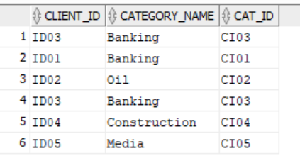

**Category:**

**DDL Create:**

create table Category(

Cat_ID varchar(25) NOT NULL PRIMARY KEY,

Category_Name varchar(25) NOT NULL,

Brokerage_Rate int NOT NULL);

**DDL Insert:**

insert into Category values ('CI01','Banking',1000);

insert into Category values ('CI02','Oil&Gas',1000);

insert into Category values ('CI03','Banking',1000);

insert into Category values ('CI04','Construction',1000);

insert into Category values ('CI05','Media',1000);

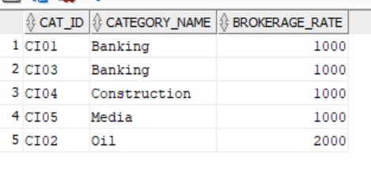

**Client strategy:**

**DDL Create:**

create table Client_strat(

Strategy_ID varchar(5) NOT NULL,

Cat_ID varchar(25) NOT NULL,

Brand_value varchar(25) NOT NULL,

Investment varchar(25) NOT NULL,

Parameter_Value int NOT NULL,

PRIMARY KEY (Strategy_ID)

);

**DDL Insert:**

insert into Client_strat values ('S01','CI01','Moderate','Low',30);

insert into Client_strat values ('S02','CI03','HIGH','Low',30);

insert into Client_strat values ('S03','CI01','Moderate','Low',30);

insert into Client_strat values ('S04','CI02','HIGH','Low',50);

insert into Client_strat values ('S05','CI03','Moderate','Low',60);

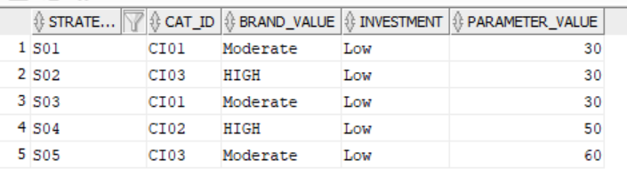

**Client:**

**DDL Create:**

Create table Client(

Client_Id varchar(5) NOT NULL PRIMARY KEY,

First_Name varchar(255) NOT NULL,

Last_Name varchar(255) NOT NULL,

Street varchar(255) NOT NULL,

Contact_Number varchar(10) NOT NULL,

SSN varchar(10) NOT NULL,

Email varchar(255) NOT NULL,

City varchar(50) NOT NULL,

State varchar(50) NOT NULL,

Zip_code varchar(10) NOT NULL

);

**DDL** **Insert**:

insert into Client values ('ID01','John', 'Mathew', 'Queensberry', 8573347890 ,0345567895,'john123@gmail.com','Boston','MA',02235);

insert into Client values ('ID03','Kate','Blanchet','Huntington',9571234567,0123890908,'kate123@gmail.com','Chicago','IL',022365);

insert into Client values ('ID02','Mike', 'King','Boston common' ,8907334790 ,0349067123,'mike123@gmail.com','Boston','MA',02218);

insert into Client values ('ID04','Josh', 'Duhamal','Boylston' ,5012345678 ,0123908768,'mike123@gmail.com','Boston','MA',02219);

insert into Client values ('ID05','Mike', 'King','Boston common' ,6012346890 ,0899067155,'mike123@gmail.com','Boston','MA',02290);

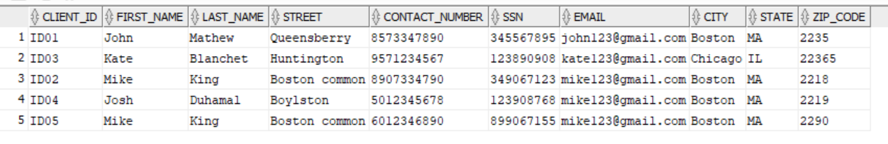

**STOCK DECISION:**

DDL Create:

create table STOCK_DECISION (

Parameter_Value int NOT NULL,

Stock_Name varchar(20),

Ticker_symbol varchar(10) NOT NULL PRIMARY KEY,

Cat_Id varchar(10) NOT NULL,

Risk varchar(10),

Brand_value varchar(10),

Investment varchar(10),

current_value int NOT NULL);

DDL Insert:

insert into STOCK_DECISION values (30, 'ICICI', 'ICI', 'CI01', 'High', 'Moderate', 'Low' , 2000);

insert into STOCK_DECISION values (40, 'BPL', 'BPL', 'CI01', 'Moderate', 'Low', 'Low' , 3000);

insert into STOCK_DECISION values (50, 'AGF', 'AGF', 'CI02', 'Low', 'High', 'Low' , 4000);

insert into STOCK_DECISION values (60, 'CVB', 'CVB', 'CI03', 'Moderate', 'Low', 'Low' , 5000);

insert into STOCK_DECISION values (70, 'AJH', 'AJH', 'CI03', 'low', 'Moderate', 'Low' , 1200);

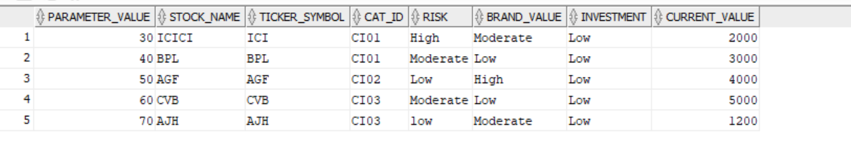

**Strategy Category:**

DDL Create:

create table Strategy_Category (

Client_ID VARCHAR(10) NOT NULL ,

Cat_ID Varchar(10) NOT NULL ,

Strategy_ID Varchar(10) NOT NULL ,

Brand_Value Varchar(25) NOT NULL ,

Investment Varchar(25) NOT NULL ,

Parameter_Value int NOT NULL )

DDL Insert:

insert into Strategy_Category values ('ID01','CI01', 'S01', 'Moderate', 'Low' ,30);

insert into Strategy_Category values ('ID01','CI03', 'S02', 'High', 'Low',30);

insert into Strategy_Category values ('ID02','CI01', 'S03', 'Low', 'Low' ,30);

insert into Strategy_Category values ('ID02','CI02', 'S04', 'High', 'Low',50);

insert into Strategy_Category values ('ID03','CI03', 'S05', 'Moderate', 'Low',60);

insert into Strategy_Category values ('ID03','CI01', 'S06', 'Moderate', 'Low' ,40);

insert into Strategy_Category values ('ID04','CI02', 'S07', 'High', 'Low',40);

insert into Strategy_Category values ('ID04','CI03', 'S08', 'Low', 'Low' ,50);

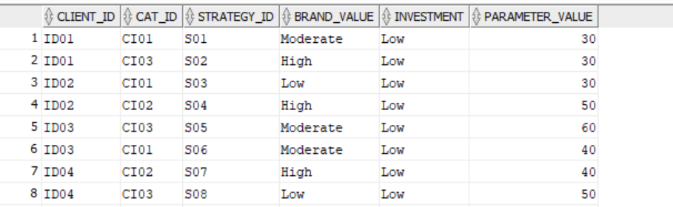

**Client Category:**

DDL Create:

create table Client_Category (

Client_ID VARCHAR(10) NOT NULL ,

Cat_ID VARCHAR(10) NOT NULL ,

Brokerage_Rate int NOT NULL)

**DDL Insert:**

insert into Client_Category values ('ID01','CI01', 1000) ;

insert into Client_Category values ('ID01','CI03', 1000) ;

insert into Client_Category values ('ID02','CI01', 1000) ;

insert into Client_Category values ('ID02','CI02', 1000) ;

insert into Client_Category values ('ID03','CI03', 1000) ;

insert into Client_Category values ('ID03','CI01', 1000) ;

insert into Client_Category values ('ID04','CI02', 1000) ;

insert into Client_Category values ('ID04','CI03', 1000) ;

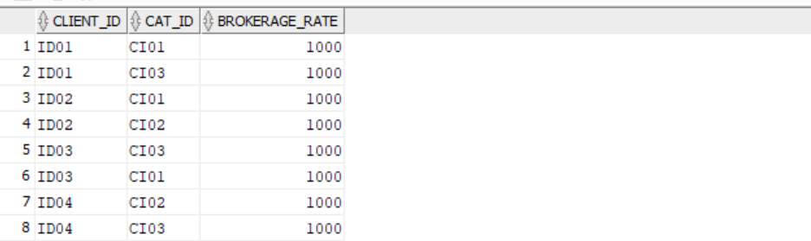

**Client stock match:**

**DDL Create:**

create table client_stock_match (

Match_id int not null PRIMARY KEY,

MATCHID varchar(15),

Client_ID varchar(10),

Strategy_ID varchar(10),

Parameter_Value int NOT NULL,

Stock_Name varchar(20),

Ticker_symbol varchar(10) NOT NULL ,

Cat_Id varchar(10) NOT NULL,

Risk varchar(10),

Brand_value varchar(10),

Investment varchar(10),

current_value int NOT NULL);

**DDL Insert:**

insert into client_stock_match

values(1,'M01','ID01','S01',30,'ICICI','ICI','CI01','High','Moderate','Low',2000);

insert into client_stock_match

values(2,'M02','ID02','S03',40,'BPL','BPL','CI01','Moderate','Moderate','Low',3000);

insert into client_stock_match

values(3,'M03','ID02','S04',50,'AGF','AGF','CI02','Low','High','Low',3000);

insert into client_stock_match

values(4,'M04','ID04','S02',40,'AGF','AGF','CI03','Low','High','Low',5000);

insert into client_stock_match

values(5,'M05','ID03','S05',60,'CVB','CVB','CI03','Moderate','Low','Low',6000);

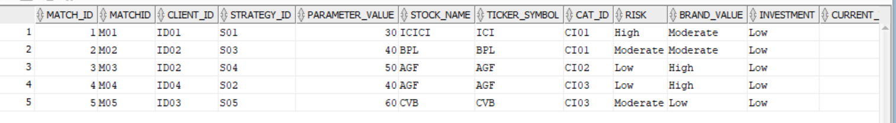

**Client_Stock_Proposal**

**DDL Create:**

Create table Client_Stock_Proposal as

(select CC.Brokerage_Rate, CS.MATCHID, CS.Stock_Name, CS.Ticker_symbol, CS.Cat_Id, CS.Current_value, CS.Client_Id

from client_stock_match CS inner join Client_Category CC

on CC.Client_Id = CS.Client_Id and CS.Cat_Id = CC.Cat_Id);

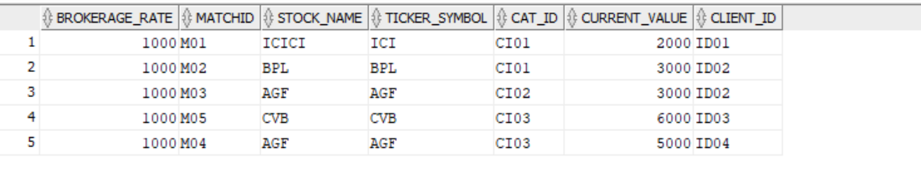

**PROPOSAL_STATUS**

**DDL Create:**

create table PROPOSAL_STATUS (

TRANS_ID VARCHAR(10) PRIMARY KEY,

MATCH_ID VARCHAR(3),

NOOFSTOCKS NUMBER(4),

STATUS VARCHAR(6),

TRANS_DATE DATE DEFAULT SYSDATE,

CONSTRAINT CHECK_STATUS CHECK(STATUS IN('ACCEPT','REJECT')));

**DDL Insert:**

insert into proposal_status values('T01','M01',5,'ACCEPT',SYSDATE);

insert into proposal_status values('T02','M02',3,'ACCEPT',SYSDATE);

insert into proposal_status values('T03','M03',7,'REJECT',SYSDATE);

insert into proposal_status values('T04','M04',10,'REJECT',SYSDATE);

insert into proposal_status values('T05','M05',5,'REJECT',SYSDATE);

insert into proposal_status values('T06','M06',20,'ACCEPT',SYSDATE);

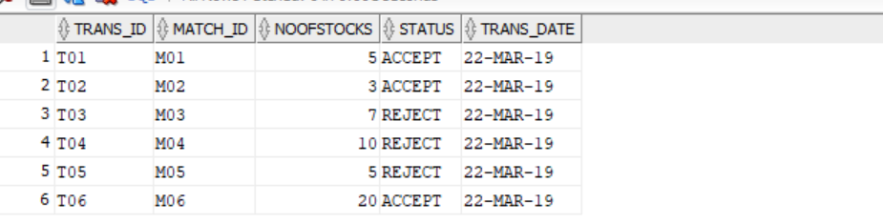

**TRANSACTION HEADER**

**DDL Create:**

create table TRANS_HEADER AS(

select p.TRANS_ID,c.client_id,c.Ticker_Symbol,c.Stock_Name,c.Cat_ID

from Client_Stock_Proposal c

inner join PROPOSAL_STATUS p

on p.MATCH_ID=c.MATCHID

and p.STATUS='ACCEPT');

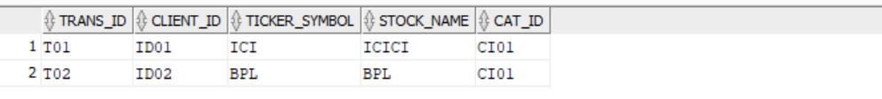

**TRANSACTION DETAILS**

**DDL Create:**  
create table TRANS_DETAIL AS(

select p.TRANS_ID,c.Ticker_Symbol,c.Stock_Name,c.Cat_ID,p.NOOFSTOCKS,c.current_value,c.brokerage_rate,p.TRANS_DATE

from Client_Stock_Proposal c

inner join PROPOSAL_STATUS p

on p.MATCH_ID=c.MATCHID

inner join TRANS_HEADER t

on t.client_id = c.client_id

and p.STATUS='ACCEPT'

);



**TRANSACTION DELETION**

**DDL Create:**

create table TRANS_DELETION AS(

select p.TRANS_ID,p.MATCH_ID,c.client_id,c.Ticker_Symbol,c.Stock_Name,p.TRANS_DATE

from Client_Stock_Proposal c

inner join PROPOSAL_STATUS p

on p.MATCH_ID=c.MATCHID

and p.STATUS='REJECT');

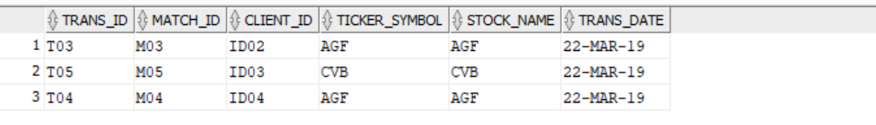

**PROFIT**

**DDL Create:**

create table PROFIT(

PROFIT_ID VARCHAR(10) PRIMARY KEY,

CLIENT_ID VARCHAR(10) NOT NULL,

TRANS_ID VARCHAR(10),

TICKER_SYMBOL VARCHAR(10) NOT NULL,

STOCK_NAME VARCHAR(20) NOT NULL,

CAT_ID VARCHAR(10) NOT NULL,

NOOFSTOCK NUMBER(4) NOT NULL,

PROFIT_AMT FLOAT NOT NULL,

BROKERAGE_RATE NUMBER(5) NOT NULL

);

**DDL Insert:**

INSERT INTO PROFIT VALUES('P01','ID01','T01','ICI','ICICI','CI01',4,50000,1000);

insert into PROFIT values('P02','ID02','T02','BPL','BPL','CI01',10,70000,1000);

insert into PROFIT values('P03','ID01','T03','AGF','AGF','CI02',15,1000000,2000);

insert into PROFIT values('P04','ID01','T04','CVB','CVB','CI03',20,30000,4000);

insert into PROFIT values('P05','ID02','T05','AGH','AGH','CI03',5,3500000,5000);

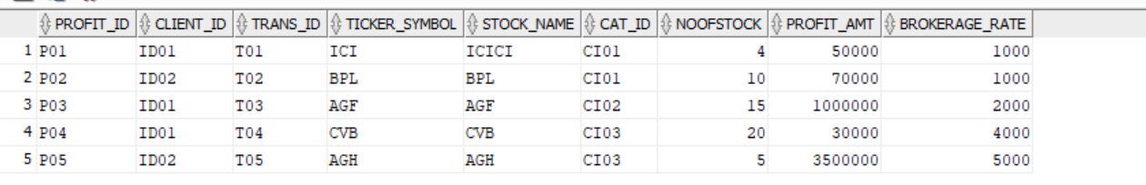

**Stock_Parameter**

**DDL Create:**

create table Stock_Parameter(

Ticker_Symbol varchar(10) PRIMARY KEY,

Cat_ID varchar(10) NOT NULL,

News int NOT NULL,

Dividends_Announced int NOT NULL,

Product_Release int NOT NULL,

New_Contract int NOT NULL,

Employee_Layoff int NOT NULL,

Takeover int NOT NULL,

Mgmt_Changes int NOT NULL,

Scandals int NOT NULL,

EPS int NOT NULL,

PE_ratio int NOT NULL,

Exchange_rate int NOT NULL);

**DDL Insert:**

insert into Stock_Parameter

values('ICI','CI01',4,6,6,12,10,14,17,15,5,7,4);

insert into Stock_Parameter

values('BPL','CI02',6,4,6,10,12,16,15,10,10,4,7);

insert into Stock_Parameter

values('AGF','CI02',4,6,6,12,10,14,17,15,5,7,4);

insert into Stock_Parameter

values('CVB','CI03',4,6,12,6,14,10,7,4,5,15,5);

insert into Stock_Parameter

values('AJH','CI03',6,4,6,5,7,4,17,15,12,10,14);

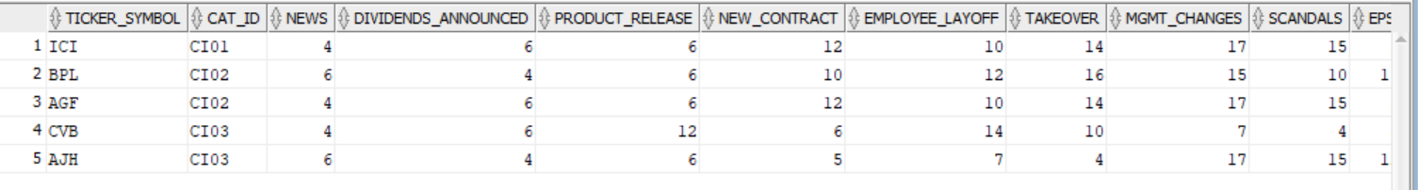

**Client Portfolio**

**DDL Create:**

create table client_portf(

Client_Id varchar(10) NOT NULL,

Category_Name varchar(25) NOT NULL,

Cat_ID Varchar(10) NOT NULL

);

**DDL Insert:**

insert into Client_portf values ('ID01','Banking','CI01');

insert into Client_portf values ('ID02','Oil','CI02');

insert into Client_portf values ('ID03','Banking','CI03');

insert into Client_portf values ('ID04','Construction','CI04');

insert into Client_portf values ('ID05','Media', 'CI05');

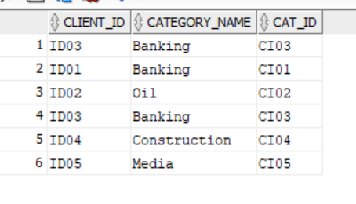

**Category**

**DDL Create:**

create table Category(

Cat_ID varchar(10) PRIMARY KEY,

Category_Name varchar(25) NOT NULL,

Brokerage_Rate int NOT NULL);

**DDL Insert:**

insert into Category values ('CI01','Banking',1000);

insert into Category values ('CI02','Oil',2000);

insert into Category values ('CI03','Banking',5000);

insert into Category values ('CI04','Construction',7000);

insert into Category values ('CI05','Media',8000);

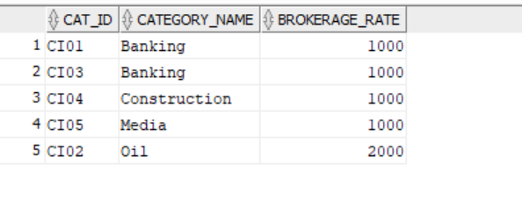

**Client Category**

**DDL Create:**

create table Client_Category as

(select p.Client_Id,c.Brokerage_Rate,p.Cat_ID

from Client_portf p

inner join Category c

on p.Cat_ID=c.Cat_ID);

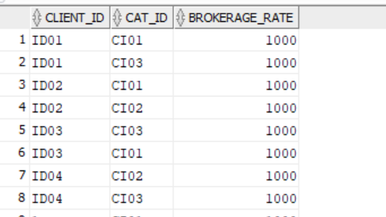

**Stock_Parameter**

**DDL Create:**

create table Stock_Parameter(

Ticker_Symbol varchar(10) PRIMARY KEY,

Cat_ID varchar(10) NOT NULL,

News int NOT NULL,

Dividends_Announced int NOT NULL,

Product_Release int NOT NULL,

New_Contract int NOT NULL,

Employee_Layoff int NOT NULL,

Takeover int NOT NULL,

Mgmt_Changes int NOT NULL,

Scandals int NOT NULL,

EPS int NOT NULL,

PE_ratio int NOT NULL,

Exchange_rate int NOT NULL);

**DDL Insert:**

insert into Stock_Parameter

values('ICI','CI01',4,6,6,12,10,14,17,15,5,7,4);

insert into Stock_Parameter

values('BPL','CI02',6,4,6,10,12,16,15,10,10,4,7);

insert into Stock_Parameter

values('AGF','CI02',4,6,6,12,10,14,17,15,5,7,4);

insert into Stock_Parameter

values('CVB','CI03',4,6,12,6,14,10,7,4,5,15,5);

insert into Stock_Parameter

values('AJH','CI03',6,4,6,5,7,4,17,15,12,10,14);

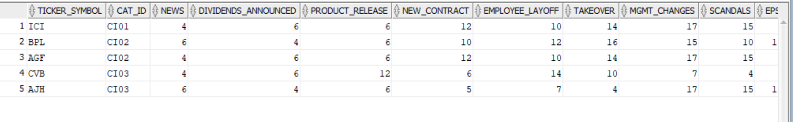

**Evaluation**

**DDL Create:**

create table evaluation as

(select Ticker_Symbol, (News+Dividends_Announced+Product_Release+New_Contract+Employee_Layoff+Takeover+Mgmt_Changes+Scandals+EPS+PE_Ratio+Exchange_Rate)as Parameter_Value

from Stock_Parameter);

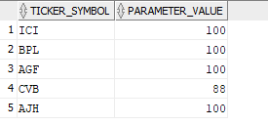

**Client Portfolio**

**DDL Create:**

create table client_portf(

Client_Id varchar(10) NOT NULL,

Category_Name varchar(25) NOT NULL,

Cat_ID Varchar(10) NOT NULL

);

**DDL Insert:**

insert into Client_portf values ('ID01','Banking','CI01');

insert into Client_portf values ('ID02','Oil','CI02');

insert into Client_portf values ('ID03','Banking','CI03');

insert into Client_portf values ('ID04','Construction','CI04');

insert into Client_portf values ('ID05','Media', 'CI05');

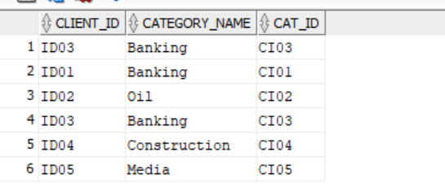

**Category**

**DDL Create:**

create table Category(

Cat_ID varchar(10) PRIMARY KEY,

Category_Name varchar(25) NOT NULL,

Brokerage_Rate int NOT NULL);

**DDL Insert:**

insert into Category values ('CI01','Banking',1000);

insert into Category values ('CI02','Oil',2000);

insert into Category values ('CI03','Banking',5000);

insert into Category values ('CI04','Construction',7000);

insert into Category values ('CI05','Media',8000);

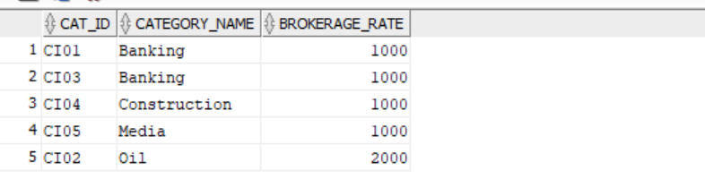

**Client_Category**

**DDL Create:**

create table Client_Category as

(select p.Client_Id,c.Brokerage_Rate,p.Cat_ID

from Client_portf p

inner join Category c

on p.Cat_ID=c.Cat_ID);

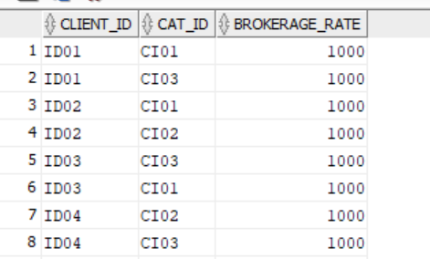

**Stock Decision**

**DDL Create:**

create table STOCK_DECISION as (SELECT Rownum as Dec_ID, e.parameter_value,S.* FROM STOCK S

inner join evaluation E on E.ticker_symbol = S.ticker_symbol) ;

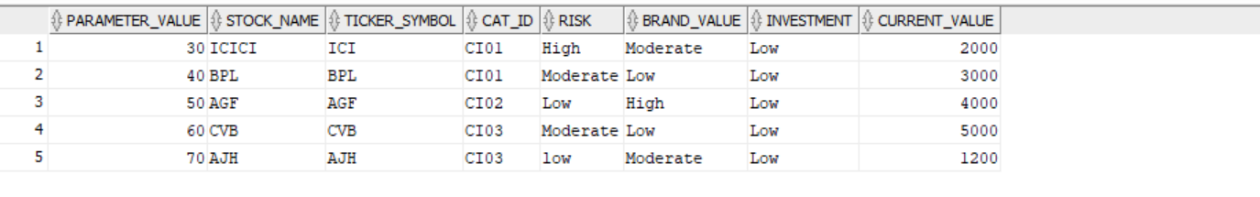

**STOCK**

**DDL Create:**

create table STOCK (

Stock_Name varchar(20),

Ticker_symbol varchar(10) NOT NULL PRIMARY KEY,

Cat_Id varchar(15) NOT NULL,

Risk varchar(10),

Brand_value varchar(10),

Investment varchar(10),

current_value int NOT NULL)

**DDL Insert:**

insert into STOCK values ('ICICI', 'ICI', 'CI01', 'High', 'Moderate', 'Low' , 2000);

insert into STOCK values ('BPL', 'BPL', 'CI01', 'Moderate', 'Low', 'Low' , 3000);

insert into STOCK values ('AGF', 'AGF', 'CI02', 'Low', 'High', 'Low' , 4000);

insert into STOCK values ('CVB', 'CVB', 'CI03', 'Moderate', 'Low', 'Low' , 5000);

insert into STOCK values ('AJH', 'AJH', 'CI03', 'low', 'Moderate', 'Low' , 1200);

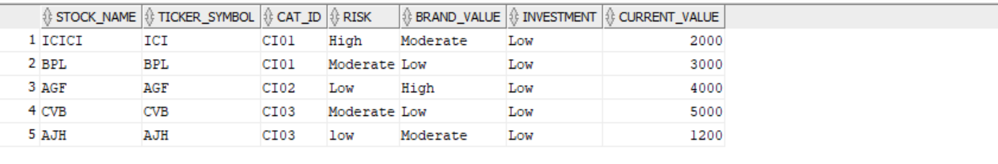

**Strategy_Category**

**DDL Create:**

create table Strategy_Category (

Client_ID int NOT NULL ,

Cat_ID Varchar(25) NOT NULL ,

Strategy_ID Varchar2(25) NOT NULL ,

Brand_Value Varchar(25) NOT NULL ,

Investment Varchar(25) NOT NULL ,

Parameter_Value int NOT NULL )

**DDL Insert:**

insert into Strategy_Category values (01,'CI01', 'S01', 'Moderate', 'Low' ,30);

insert into Strategy_Category values (01,'CI03', 'S02', 'High', 'Low',30);

insert into Strategy_Category values (02,'CI01', 'S03', 'Low', 'Low' ,30

insert into Strategy_Category values (02,'CI02', 'S04', 'High', 'Low',50);

insert into Strategy_Category values (03,'CI03', 'S05', 'Moderate', 'Low',60);

insert into Strategy_Category values (03,'CI01', 'S06', 'Moderate', 'Low' ,40);

insert into Strategy_Category values (04,'CI02', 'S07', 'High', 'Low',40);

insert into Strategy_Category values (04,'CI03', 'S08', 'Low', 'Low' ,50);

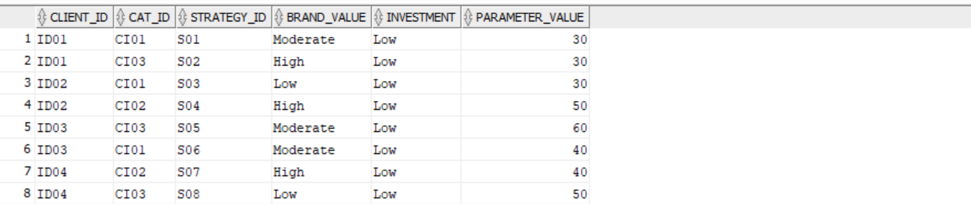

**Client_Category**

**DDL Create:**

create table Client_Category (

Client_ID int NOT NULL ,

Cat_ID Varchar(25) NOT NULL ,

Brokerage_Rate int NOT NULL)

**DDL Insert:**

insert into Client_Category values (01,'CI01', 1000) ;

insert into Client_Category values (01,'CI03', 1000) ;

insert into Client_Category values (02,'CI01', 1000) ;

insert into Client_Category values (02,'CI02', 1000) ;

insert into Client_Category values (03,'CI03', 1000) ;

insert into Client_Category values (03,'CI01', 1000) ;

insert into Client_Category values (04,'CI02', 1000) ;

insert into Client_Category values (04,'CI03', 1000) ;

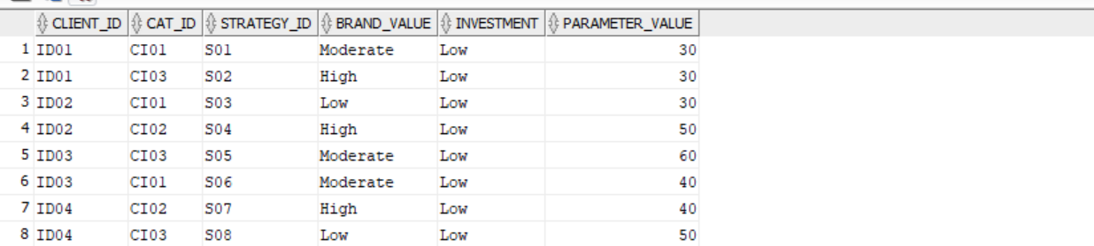

**Citations:**

* https://www.w3schools.com/sql/
* https://www.geeksforgeeks.org/structured-query-language/
* https://www.tutorialspoint.com/sql/sql-select-query.htm